- Program ID : VI004MA1

- Display Layout
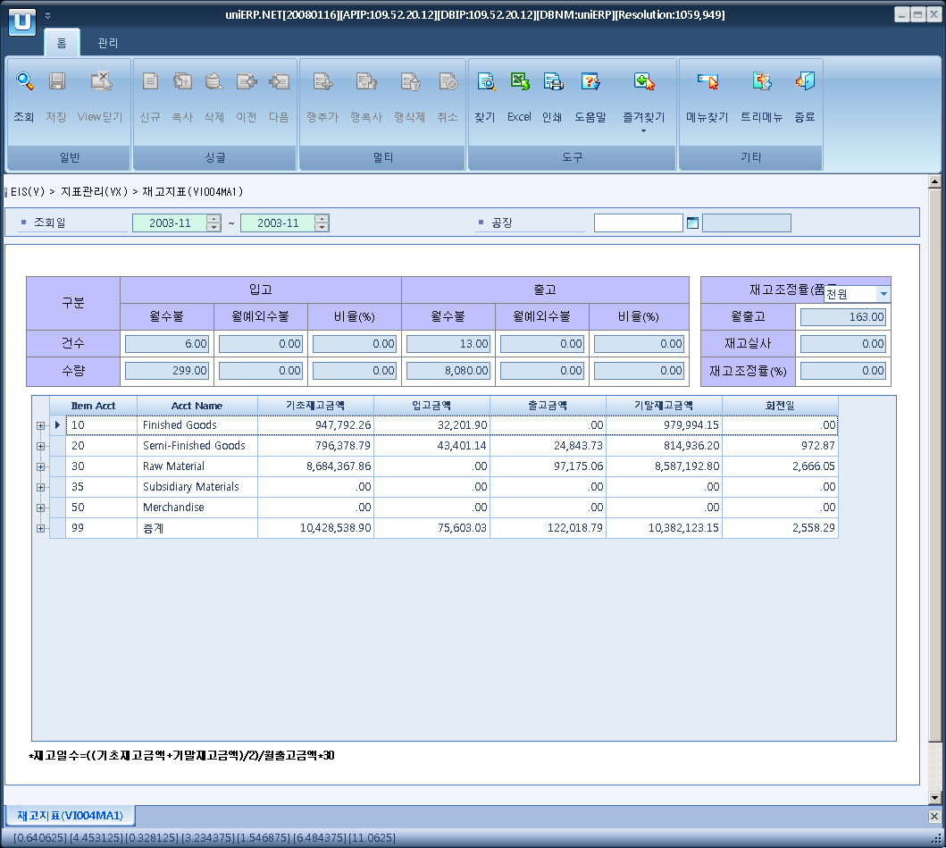

- Event flow
- Click Query button
- OnFncQuery -> DbQuery -> DataChange
- Display Unit combo change
- uniCombo1_ValueChanged -> DataChange

- SQL Statements
- Incomming count
SELECT COUNT(DISTINCT CASE SUBSTRING(b.trns_type, 2, 1) WHEN 'R' THEN a.item_document_no ELSE NULL END) AS rcpt_cnt, -- 입고건수
SUM(CASE SUBSTRING(b.trns_type, 2, 1) WHEN 'R' THEN b.qty ELSE 0 END *
CASE b.debit_credit_flag WHEN 'C' THEN -1 ELSE 1 END) AS rcpt_qty, -- 입고수량
COUNT(DISTINCT CASE b.trns_type WHEN 'OR' THEN a.item_document_no ELSE NULL END) AS exc_rcpt_cnt, -- 예외입고건수
SUM(CASE b.trns_type WHEN 'OR' THEN b.qty ELSE 0 END *
CASE b.debit_credit_flag WHEN 'C' THEN -1 ELSE 1 END) AS exc_rcpt_qty, -- 예외입고수량
COUNT(DISTINCT CASE SUBSTRING(b.trns_type, 2, 1) WHEN 'I' THEN a.item_document_no ELSE NULL END) AS issue_cnt, -- 출고건수
SUM(CASE SUBSTRING(b.trns_type, 2, 1) WHEN 'I' THEN b.qty ELSE 0 END *
CASE b.debit_credit_flag WHEN 'C' THEN 1 ELSE -1 END) AS issue_qty, -- 출고수량
COUNT(DISTINCT CASE b.trns_type WHEN 'OI' THEN a.item_document_no ELSE NULL END) AS exc_issue_cnt, -- 예외출고건수
SUM(CASE b.trns_type WHEN 'OI' THEN b.qty ELSE 0 END *
CASE b.debit_credit_flag WHEN 'C' THEN 1 ELSE -1 END) AS exc_issue_qty, -- 예외출고수량
COUNT(DISTINCT CASE WHEN a.trns_type = 'OI' AND b.mov_type = 'I91' THEN b.item_cd ELSE NULL END) AS adj_cnt -- 조정건수
FROM i_goods_movement_header a
INNER JOIN i_goods_movement_detail b
ON b.item_document_no = a.item_document_no
AND b.document_year = a.document_year
AND b.delete_flag = 'N'
AND b.qty <> 0
WHERE a.document_dt >= CONVERT(DATETIME, @strYear + @strFrMonth + '01')
AND a.document_dt < DATEADD(MONTH, 1, CONVERT(DATETIME, @strYear + @strToMonth + '01'))
AND a.plant_cd LIKE @strPlantCd

- Inventory adjustment
SELECT COUNT(DISTINCT item_cd) AS inv_cnt
FROM i_monthly_inventory
WHERE mnth_inv_year = @strYear
AND mnth_inv_month BETWEEN @strFrMonth AND @strToMonth
AND plant_cd LIKE @strPlantCd
- Inventory status by goods
SELECT ISNULL(a.item_acct, '99') AS item_acct,
ISNULL(b.minor_nm, '총계') AS item_acct_nm,
a.item_cd, c.item_nm,
a.bas_inv_amt, a.rcpt_amt, a.issue_amt, a.inv_amt,
CASE WHEN a.issue_amt = 0 THEN 0
ELSE (a.bas_inv_amt + a.inv_amt) / 2 / a.issue_amt * 30 *
(CONVERT(DECIMAL, @strToMonth) - CONVERT(DECIMAL, @strFrMonth) + 1)
END AS inv_days
FROM (SELECT b.item_acct, b.item_cd,
SUM(CASE a.mnth_inv_month WHEN @strFrMonth THEN a.bas_inv_amt ELSE 0 END) AS bas_inv_amt,
SUM(a.rcpt_amt) AS rcpt_amt,
SUM(a.issue_amt) AS issue_amt,
SUM(CASE a.mnth_inv_month WHEN @strToMonth THEN a.inv_amt ELSE 0 END) AS inv_amt
FROM i_monthly_inventory a
INNER JOIN b_item_by_plant b
ON b.plant_cd = a.plant_cd
AND b.item_cd = a.item_cd
WHERE a.mnth_inv_year = @strYear
AND a.mnth_inv_month BETWEEN @strFrMonth AND @strToMonth
AND a.plant_cd LIKE @strPlantCd
GROUP BY b.item_acct, b.item_cd WITH ROLLUP) a
LEFT JOIN b_minor b
ON b.minor_cd = a.item_acct
AND b.major_cd = 'P1001'
LEFT JOIN b_item c
ON c.item_cd = a.item_cd
ORDER BY a.item_acct, a.item_cd

